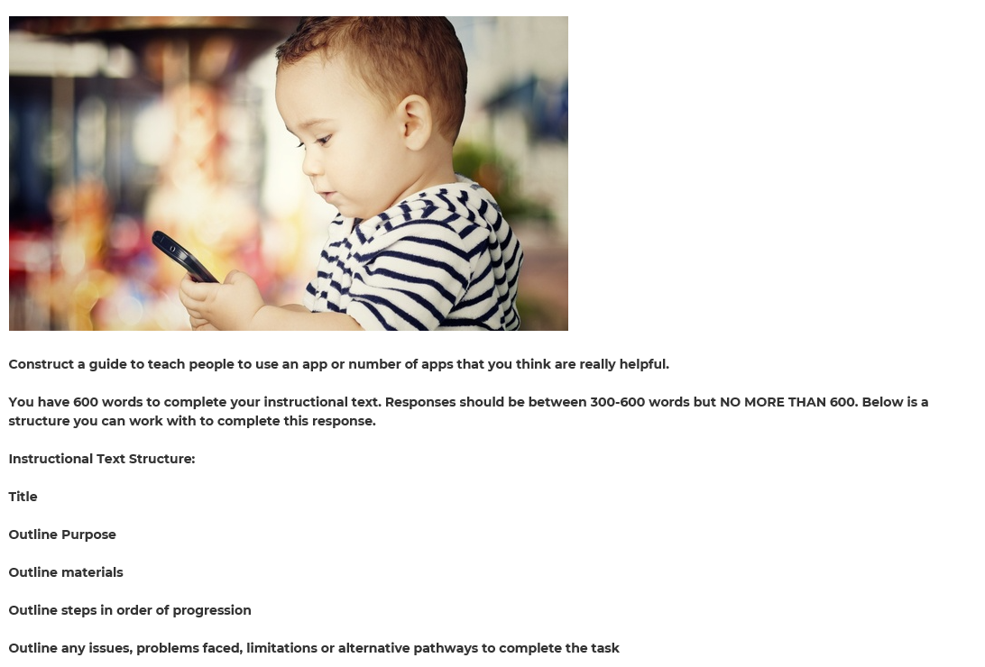

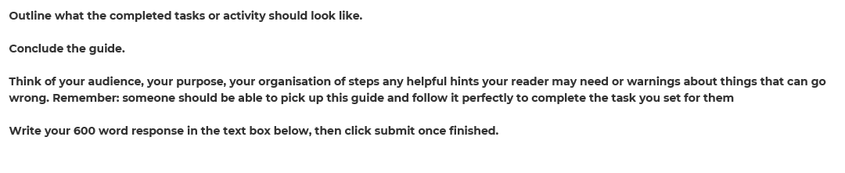**SAMPLE TEXT**

**Title:** How to use Instagram- A beginner’s guide.   
**Purpose:** By the end of this you should know how to use Instagram.   
**Materials Required:** The materials you will need are:  
- a smart phone                                - a tablet                                              - Computer

- Laptop   
**Step 1:** Go onto the App Store on your device and type "Instagram" into the search tab (**HINT:** on an ipad you will have to change it to “iphone only” in the tab at the top to get the correct app to come up)   
  
**Step 2:** When you receive the search results look for a picture of a camera in a curved square and it should say “Instagram” in a flowing font. Press the "get" button to download it. (**WARNING:** You may be prompted to put your password in, when you have done this, it will work) Wait till it has downloaded and then press on the new camera in a rounded square icon.   
  
**Step 3:** When you get onto the app, you will have to create an “account sign in” so press the “sign up” button or if you have Facebook account, you can log in automatically by pressing the “Link to Facebook” button.   
  
**Step 4:** Once you have followed the steps and created a login or logged in using Facebook, you will be taken to your home page and this is where all your photos of people that you “follow” will come up. You can scroll up and down to see these photos and you can double tap on and photo to show you “like it” in a similar way to Facebook (**WARNING:** it is easy to accidentally double-tap an image when you are scrolling down too fast so be careful). You can also press on the picture of a speech bubble with three dots inside it to comment on a photo.   
  
**Step 5:** When you press on the magnifying glass icon next to the house you can search for specific people by typing in the window which will allow you to see other photos from people you aren't following at that moment. At any time you can decide to follow them by clicking the “follow” button.   
  
**Step 6:** To post a photo or video you press on the little blue button which looks like a square with a circle inside it next to the magnifying glass. This will access your camera or camera roll so you can see your collection of photos.  You can select the image you would like to post simply by clicking on it and pressing next. You can also click on the “capture icon” to start filming something that will be loaded onto Instagram.   
  
**Step 7:** When you are happy with the picture or video you can press the blue “next” button and it will come up with the image you have chosen so you can change, edit or adjust it. In the next menu you will see tabs and options so you can add effects, alter the colour, resize the image or crop it and you can even add emojis or other icons onto the photos from this menu.   
  
**Step 8:** When you press the blue “next” button again, you will see a new window up the top where it says "write a caption." Here you can type something about the picture and then “Tag” other people who you want to see it or who are involved in the image (**HINT:** which draws from your friends list on Facebook). You can also click “add location” to show where you took the photo from.   
  
**Step 9:** If you would like to share it on Facebook, Twitter, Tumblr or Flicker you can by clicking the blue “Share” button. Only your friends on Facebook and your followers on Facebook will be able to view the post.   
  
I hope this information is helpful for you and you better understand the man functions and setup of the app Instagram. Have fun taking, editing and sharing your photos.